Check off the following once you completed the task!

- ________ 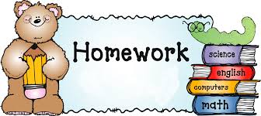Check homework book and complete ALL assignments.

- ________
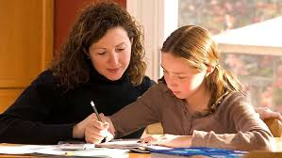 Have mom or an adult check over your homework with you.

- ________ Have mom, dad, or an adult read/time you with your fluency practice.

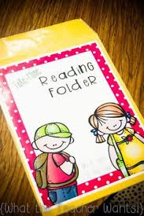 and
- Put materials in school bag and return to school!!!

